# Machine Learning Week 3 Progress Report

Group Members:

Aarya Parekh AU2120075

Diya Patel AU2120193

Kavyan Savani AU2120231

Vatsal Shah AU2040082

12-02-2024

Instead of further exploring clustering algorithms, we decided to at least try and reproduce the results showcased by Barmpounakis et al [1]. To do so, we initially downloaded the dataset in Tuesday’s class and thoroughly analyzed how to go about reproducing the results. The dataset provides us details of individual vehicles but does not give any sort of hints about which road the vehicle is on. Due to this, the first problem that we encountered was how do we define whether two vehicles are on the same road. Lane detection would be of a much later concern. In the paper by Barmpounakis et al [1], they calculate the number of lanes based on measuring the distance from the edge of the road, but it is nowhere mentioned how they calculated the edge of the road as it is neither present in the dataset nor is there any explanation of how they calculated it. Thus, we hit the second major roadblock.

15-02-2024

Instead of focusing on the road and road-edge detection problem, we worked on a problem that we could tackle! Finding the Azimuth angle or the direction of the movement of the vehicle. We implemented a working code to load the dataset from the CSV file downloaded from [2] with the option to filter out specific rows that might introduce noise, and also to plot the dataset to better visualize it. We also have an almost working code that finds the azimuth angle in between each consecutive frame for every vehicle in the dataset.

**PFA the images of the plot of the dataset, as well as the execution flow of the lane detection algorithm provided by Barmpounakis et al [1]. The points in the plot showcase the starting points for different vehicles at time t=0. The “apparent” lines and cross-sections created by the points hints at the grid structure of the roads in the dataset.**

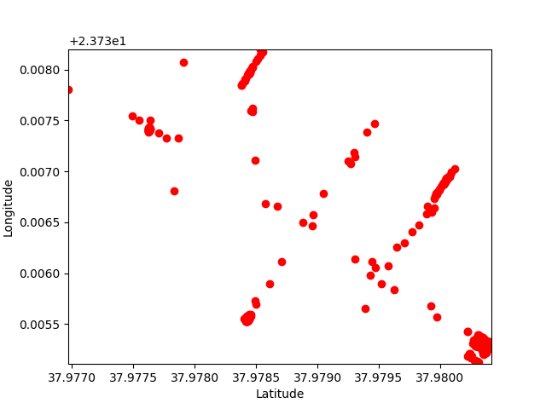

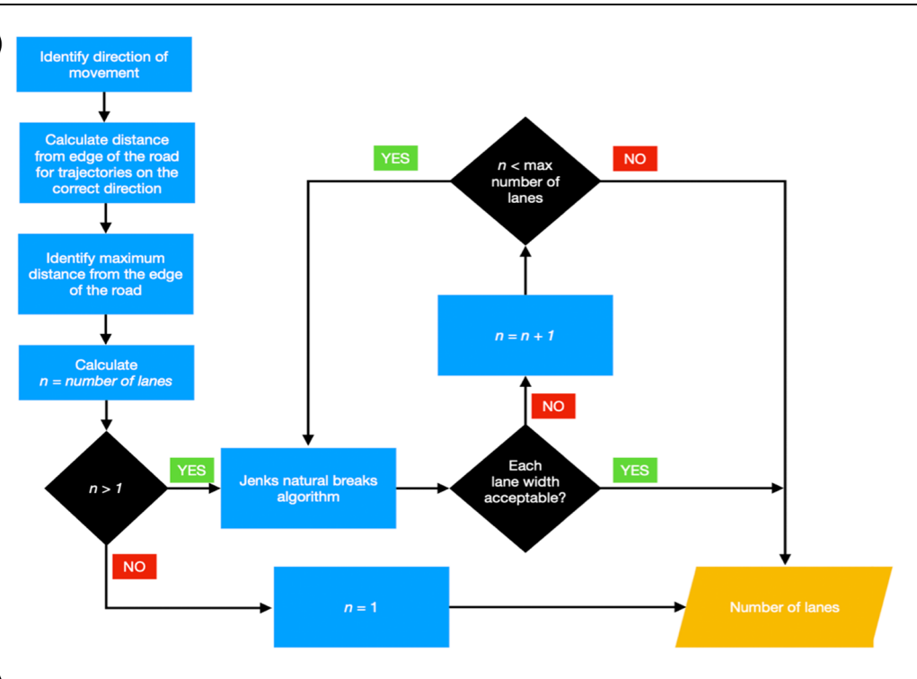

References

1. Barmpounakis, Emmanouil, Guillaume M. Sauvin, and Nikolaos Geroliminis. "Lane detection and lane-changing identification with high-resolution data from a swarm of drones." Transportation research record 2674.7 (2020): 1-15.
2. pNEUMA Downloads - <https://open-traffic.epfl.ch/index.php/downloads/>